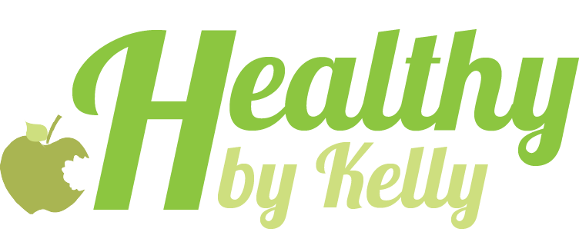
healthybykelly.weebly.com
www.kellymarieharkins.com

YOUR BEST BOOTY WORKOUT

- 15 Right and 15 Left Leg Squat Kickbacks.
Rest 15-30 seconds
- 15 Right and 15 Left Squat Side Kicks.
Rest 15-30 seconds.

These next exercises are to be done straight through with no rest between

- 25 Floor Bridges- wide
- 25 Floor Bridges- narrow
- 15 Floor Bridges- wide *ON LAST REP: hold at top and tap knees together 20 times
- 15 Floor Bridges- wide
- 10 Floor Bridges- narrow

Rest for 1 minute.

These next exercises are done on your hands and knees and should be completed continuously through in the order listed for the right leg. Rest. Then complete all for the left leg.

- 15 'all fours' kickback
- 15 'all fours' leg curls
- 15 'all fours' leg curl pump

